Отчёт

Кластерные индексы

--CLUSTERED

--Unique

CREATE CLUSTERED INDEX ID_Cars

ON Cars (IDCar)

SET STATISTICS IO ON;

SET STATISTICS TIME ON;

SELECT *

FROM Clients WHERE IDClient > 100;

SET STATISTICS IO OFF;

SET STATISTICS TIME OFF;

DROP INDEX ID_Cars ON Cars

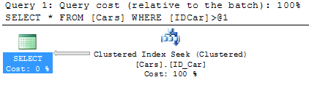

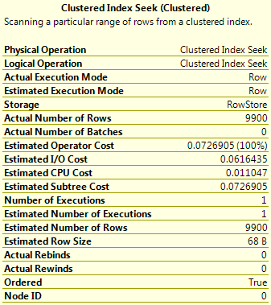

--Non-indexed

SET STATISTICS IO ON;

SET STATISTICS TIME ON;

SELECT *

FROM Clients WHERE IDClient > 100;

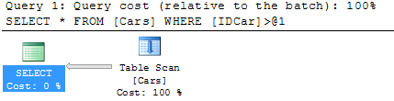

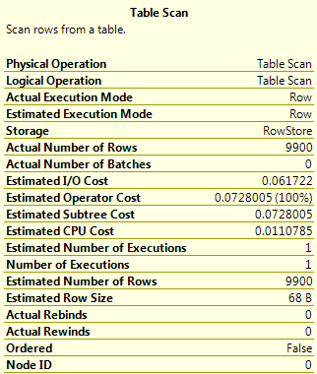

--Composite

CREATE CLUSTERED INDEX IDClient_Year_INDEX

ON [dbo].[Cars] (IDClient, [Year])

SET STATISTICS IO ON;

SET STATISTICS TIME ON;

SELECT IDClient, [Year]

FROM [dbo].[Cars]

WHERE IDClient BETWEEN 1000 AND 8000 AND [Year] > 2003;

SET STATISTICS IO OFF;

SET STATISTICS TIME OFF;

DROP INDEX IDClient_Year_INDEX

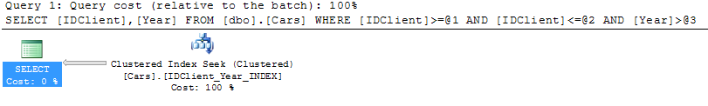

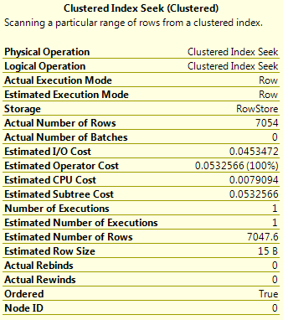

--Non-indexed

SET STATISTICS IO ON;

SET STATISTICS TIME ON;

SELECT IDClient, [Year]

FROM [dbo].[Cars]

WHERE IDClient BETWEEN 1000 AND 8000 AND [Year] > 2003;

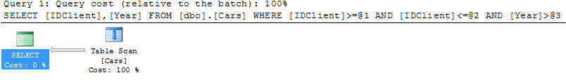

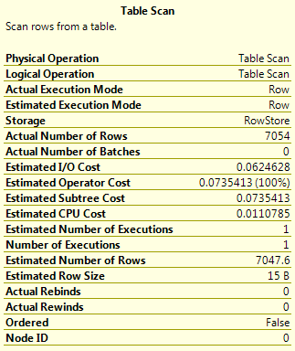

--Covering

CREATE CLUSTERED INDEX ALL_COLLUMNS_INDEX

ON Cars (IDCar, IDClient, NCar, Model, [Year], Color)

SET STATISTICS IO ON;

SET STATISTICS TIME ON;

SELECT IDCar, IDClient, NCar, Model, [Year], Color

FROM Cars

WHERE [Year] > 2003 AND LEN(Model) > 4

SET STATISTICS IO OFF;

SET STATISTICS TIME OFF;

DROP INDEX ALL_COLLUMNS_INDEX ON Cars;

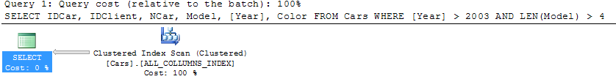

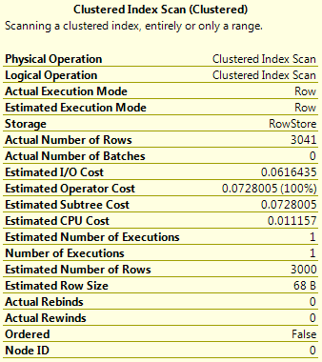

--Non-indexed

SET STATISTICS IO ON;

SET STATISTICS TIME ON;

SELECT IDCar, IDClient, NCar, Model, [Year], Color

FROM Cars

WHERE [Year] > 2003 AND LEN(Model) > 4

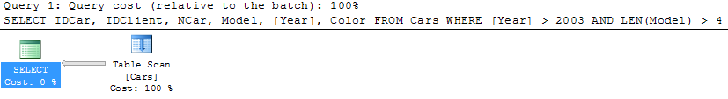

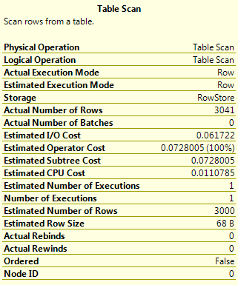

--Composite index again

--having

CREATE CLUSTERED INDEX IDCar_Model_Color_INDEX

ON Cars (IDCar, Model, Color)

SET STATISTICS IO ON;

SET STATISTICS IO ON;

SELECT COUNT(Color) AS N'Варианты окраски', Model

FROM Cars

GROUP BY Model

HAVING COUNT(Color) > 5

ORDER BY COUNT(Color) DESC

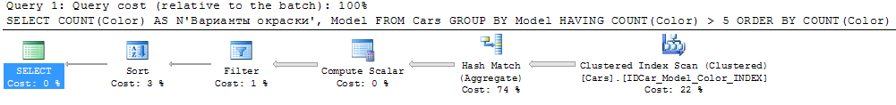

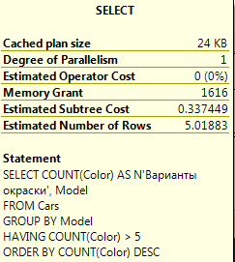

--Non-indexed

--having

SELECT COUNT(Color) AS N'Варианты окраски', Model

FROM Cars

GROUP BY Model

HAVING COUNT(Color) > 5

ORDER BY COUNT(Color) DESC

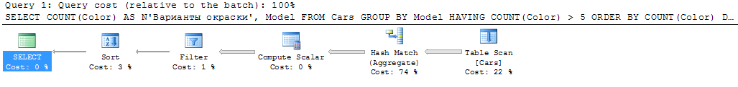

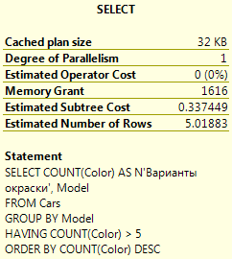

Некластерные индексы

--NONCLUSTERED

--Unique

CREATE NONCLUSTERED INDEX IDClient_INDEX

ON Cars (IDCar, IDClient)

SET STATISTICS IO ON;

SET STATISTICS TIME ON;

SELECT Cars.IDClient, Clients.Surname

FROM Cars INNER JOIN Clients ON Cars.IDClient = Clients.IDClient

WHERE IDCar > 100

SET STATISTICS IO OFF;

SET STATISTICS TIME OFF;

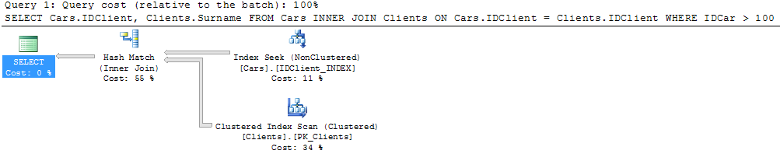

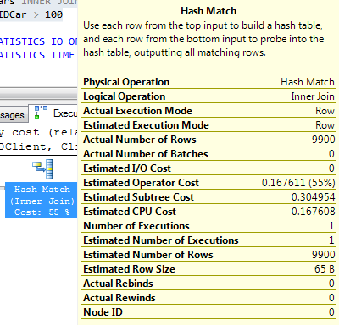

С индексом операция Hash Match вносит больший вклад в общее время, по сравнению с поиском по индексу.

--Non-indexed

SET STATISTICS IO ON;

SET STATISTICS TIME ON;

SELECT Cars.IDClient, Clients.Surname

FROM Cars INNER JOIN Clients ON Cars.IDClient = Clients.IDClient

WHERE IDCar > 100

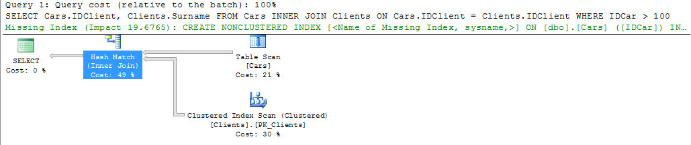

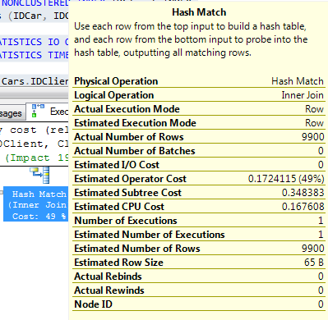

--Composite

CREATE NONCLUSTERED INDEX IDContract_IDClient_INDEX

ON [Contract] (IDContract, IDClient)

SET STATISTICS IO ON;

SET STATISTICS TIME ON;

SELECT IDContract, IDClient

FROM [Contract]

WHERE IDContract IN(1, 101) AND IDClient > 1

SET STATISTICS IO OFF;

SET STATISTICS TIME OFF;

DROP INDEX IDContract_IDClient_INDEX ON [Contract]

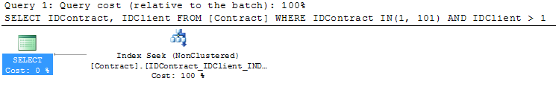

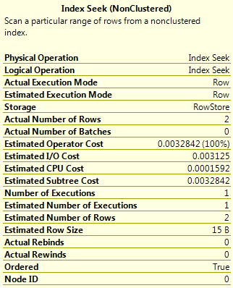

--Non-indexed

SELECT IDContract, IDClient

FROM [Contract]

WHERE IDContract IN(1, 101) AND IDClient > 1

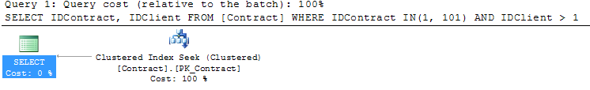

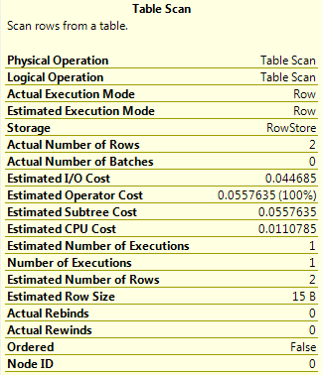

--Covering

CREATE NONCLUSTERED INDEX IDContract_IDClient_Data_TotalSum_INDEX

ON [Contract] (IDContract, IDClient, Data, TotalSum)

SET STATISTICS IO ON;

SET STATISTICS TIME ON;

SELECT IDContract, IDClient, Data, TotalSum

FROM [Contract]

WHERE TotalSum > 2500 AND Data BETWEEN CONVERT(datetime, '26.05.1998', 104) AND CONVERT(datetime, '28.09.2003', 104)

DROP INDEX IDContract_IDClient_Data_TotalSum_INDEX ON [Contract]

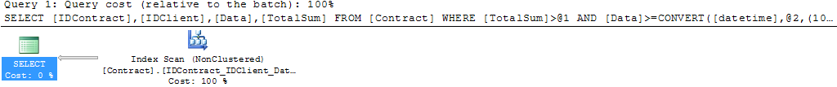

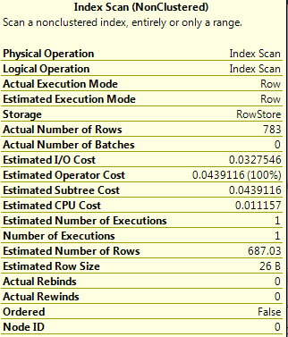

--Non-indexed

SELECT IDContract, IDClient, Data, TotalSum

FROM [Contract]

WHERE TotalSum > 2500 AND Data BETWEEN CONVERT(datetime, '26.05.1998', 104) AND CONVERT(datetime, '28.09.2003', 104)

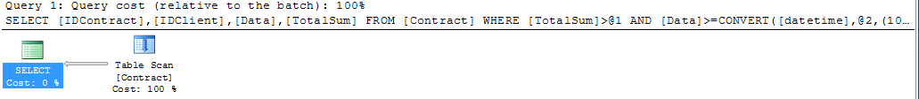

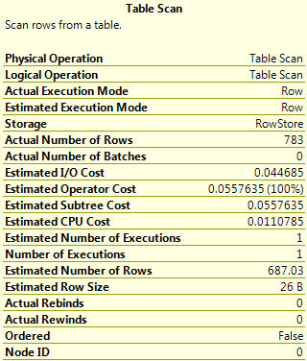

--Index with Included Columns

CREATE NONCLUSTERED INDEX DeadLine_Index

ON [Contract] (IDClient, TechnicalPassport)

INCLUDE(FinishDateContract)

SET STATISTICS IO ON;

SET STATISTICS TIME ON;

SELECT [Contract].IDClient, Surname, Name, TechnicalPassport, FinishDateContract AS N'Срок окончания работ'

FROM [Contract] INNER JOIN Clients ON [Contract].IDClient = Clients.IDClient

WHERE FinishDateContract BETWEEN CONVERT(datetime, '26.05.1998', 104) AND CONVERT(datetime, '28.09.2016', 104)

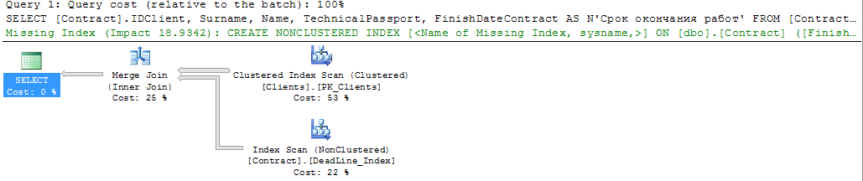

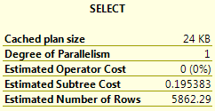

--Non-indexed

SET STATISTICS IO ON;

SET STATISTICS TIME ON;

SELECT [Contract].IDClient, Surname, Name, TechnicalPassport, FinishDateContract AS N'Срок окончания работ'

FROM [Contract] INNER JOIN Clients ON [Contract].IDClient = Clients.IDClient

WHERE FinishDateContract BETWEEN CONVERT(datetime, '26.05.1998', 104) AND CONVERT(datetime, '28.09.2016', 104)

